Musician’s Dialect screenshots

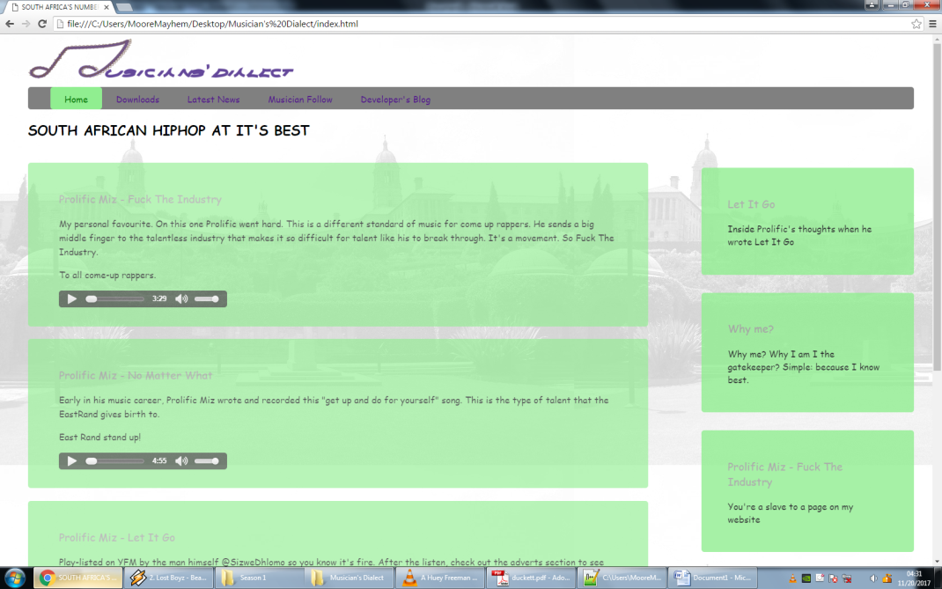

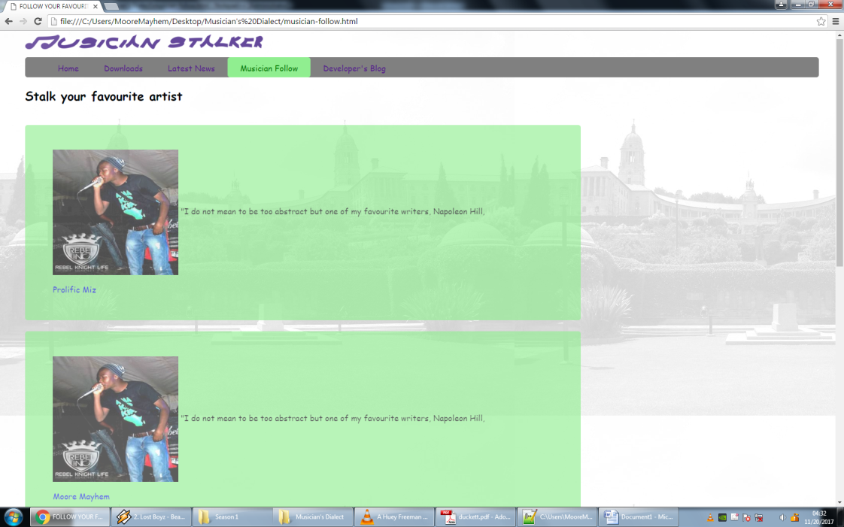Home page complete with latest and hottest songs.

Musician stalker page with all artist biographies, what they do(e.g rapper, producer) and the enterprise they represent

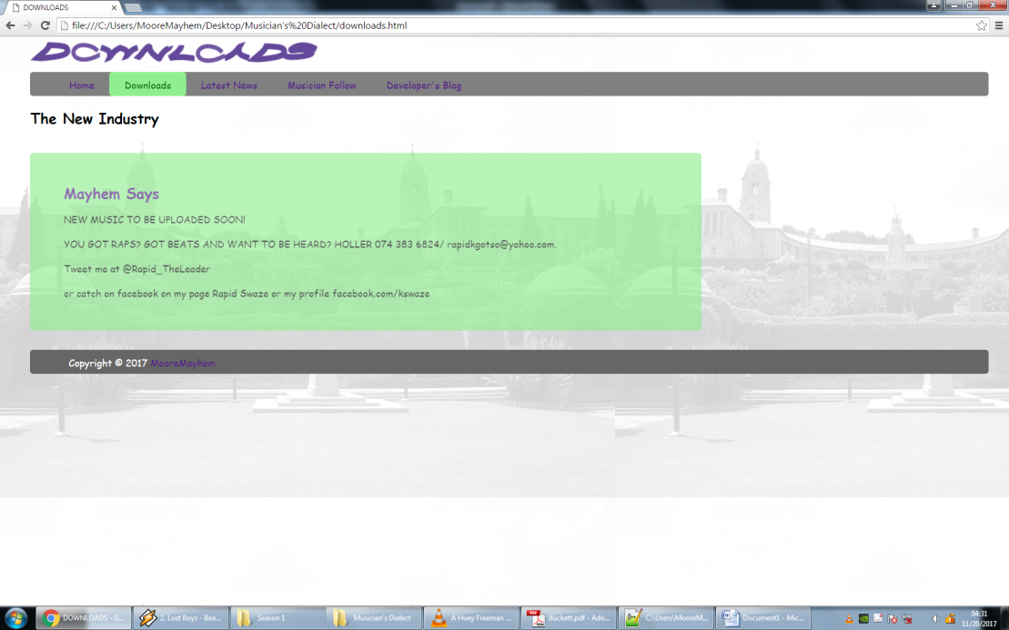

Downloads page to have all the songs, beats and art work posted by artists.

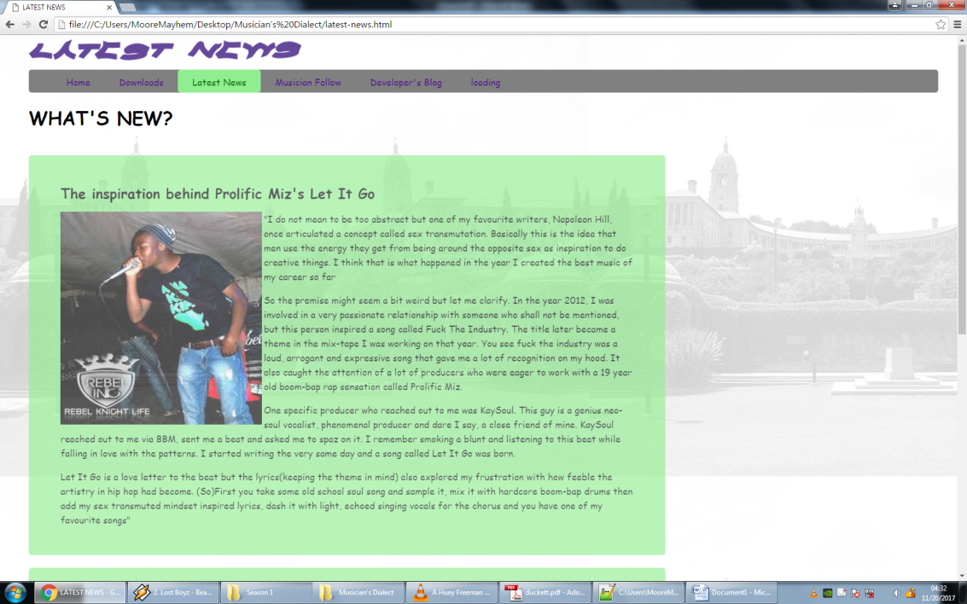

Latest news page with all information on latest events to occur, breaking news and future events of artists.